Testing document for MS Decom activities

Project: Z_FD45_QSPL_QUA

System : xFE

CD: 151938.

Transport request: DFEK962733

—---------------------------------------------------------------------------------------------------------------------------------

1. Open the application from the Fiori launchpad and click on **Go** button after entering selection criteria. It will give below results.

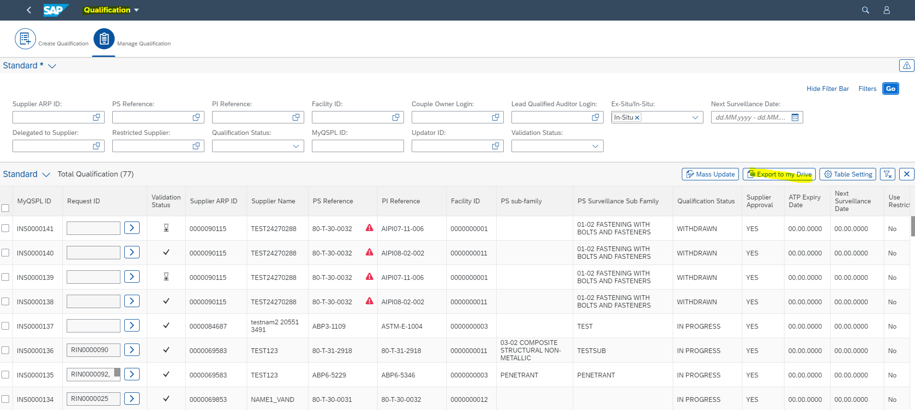

1. Below google sheet will open on action of the Export to my Drive button.

